# **Lab 1.2 Linux**

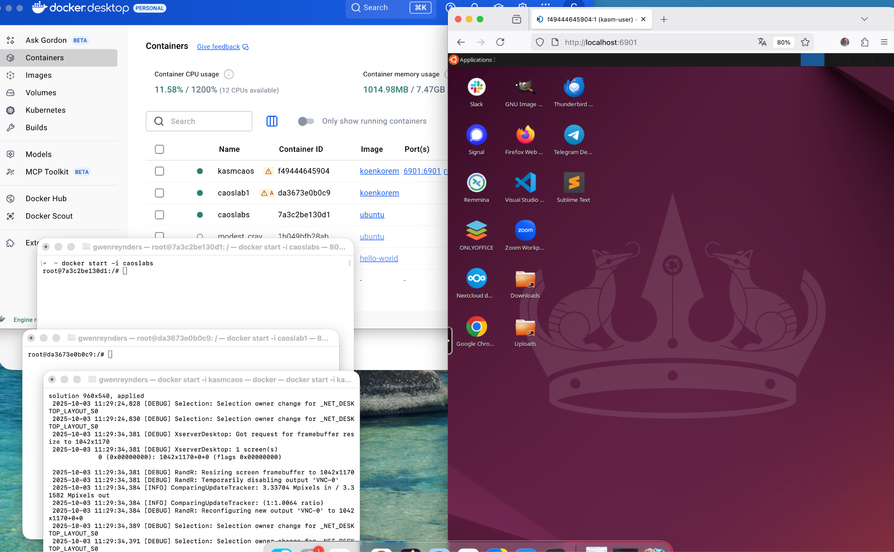

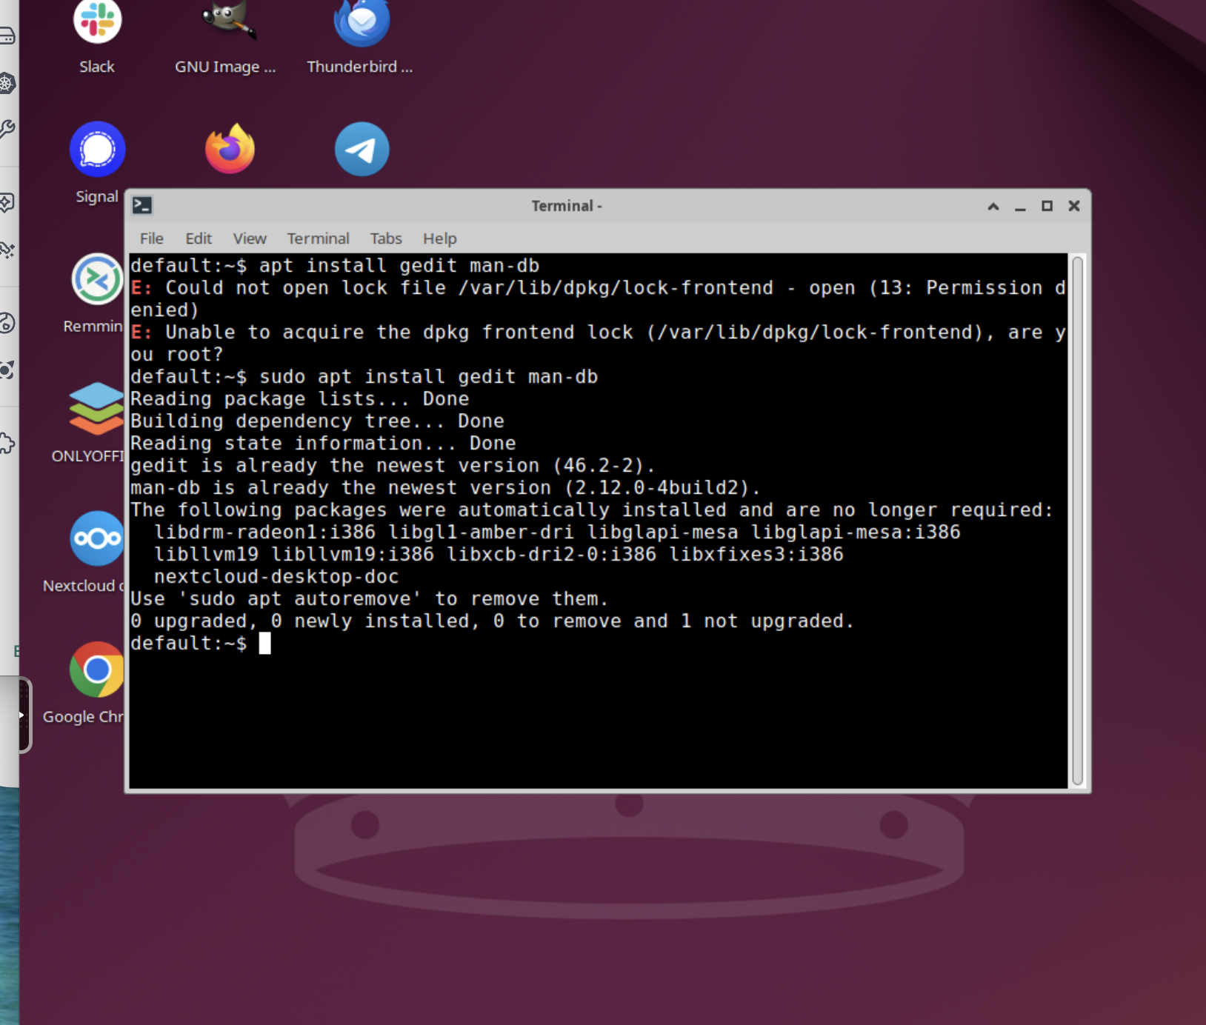

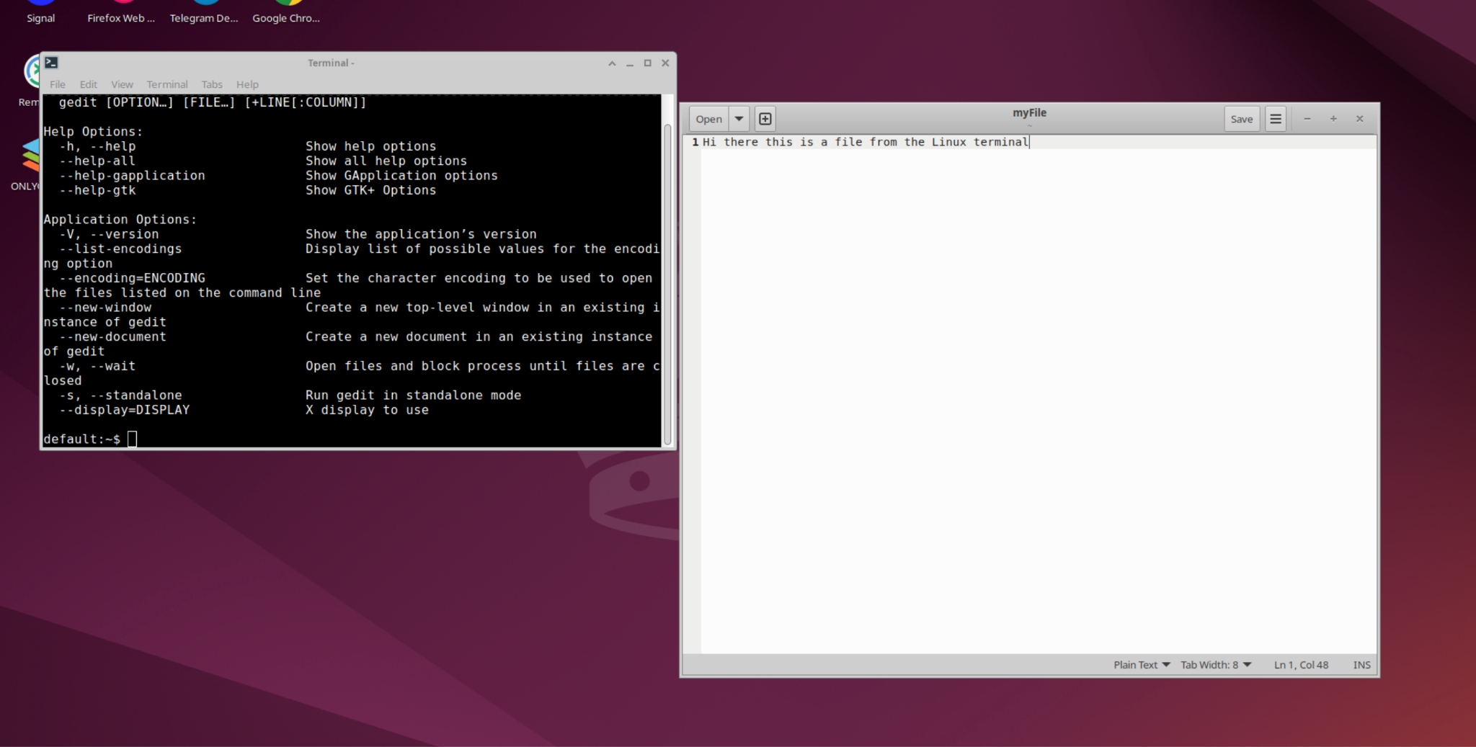

1. Create a file on the desktop and find it back with the terminal using this command echo 'my new file' > ~/mynewfile

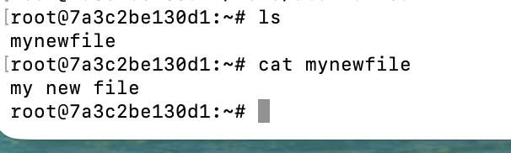

1. Show all files and folders in the */etc* directory

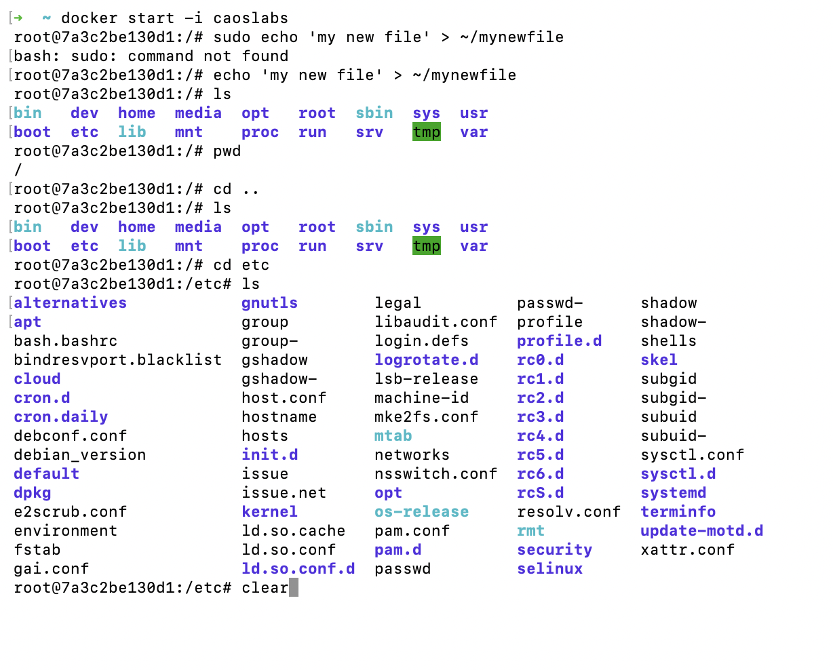

1. Use a command to clear the screen

Zie hierboven !!  
clear

1. Find in the manual all apt possibilities, for example apt install

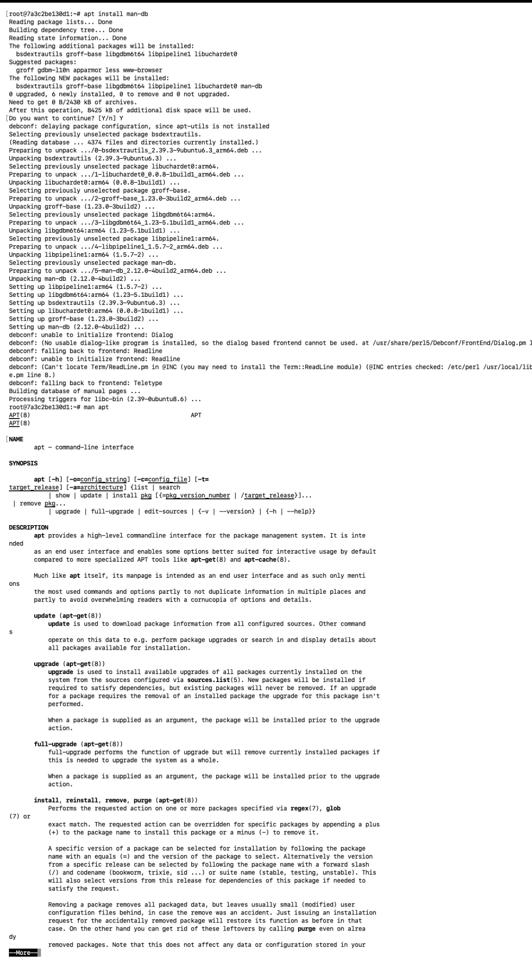

1. Find all commands with *date*

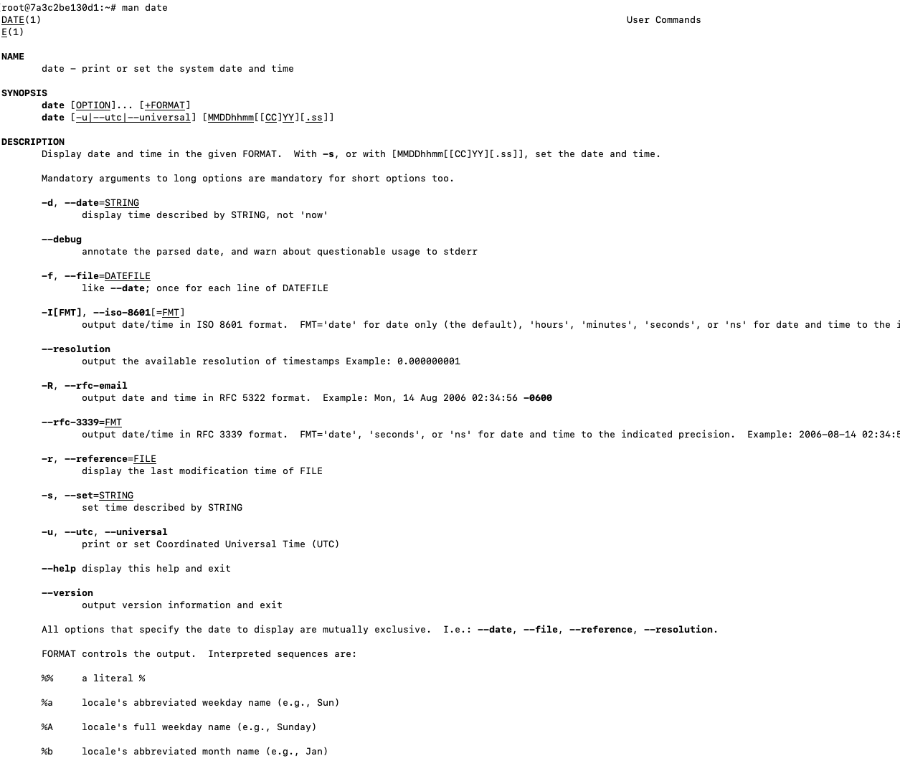

1. How can you repeat that command without typing it again?

Als je met de pijltjes naar boven gaat dan komt het laatste ingetypte terug. als je 2 keer clickt dan komt hetgeen daarvoor ingetypt is tevoorschijn. ja kan dan met de pijltjes op en neer gaan. ( boven en onder )  
  
other way to go to the next page

1. other way to go back to the previous page
2. search in the man page
3. go to the next search result
4. go to the previous result

Most commands optionally preceded by integer argument k. Defaults in brackets.

Star (*) indicates argument becomes new default.

-------------------------------------------------------------------------------

<space> Display next k lines of text [current screen size]

z Display next k lines of text [current screen size]*

<return> Display next k lines of text [1]*

d or ctrl-D Scroll k lines [current scroll size, initially 11]*

q or Q or <interrupt> Exit from more

s Skip forward k lines of text [1]

f Skip forward k screenfuls of text [1]

b or ctrl-B Skip backwards k screenfuls of text [1]

' Go to place where previous search started

= Display current line number

/<regular expression> Search for kth occurrence of regular expression [1]

n Search for kth occurrence of last r.e [1]

!<cmd> or :!<cmd> Execute <cmd> in a subshell

v Start up '/usr/bin/vi' at current line

ctrl-L Redraw screen

:n Go to kth next file [1]

:p Go to kth previous file [1]

:f Display current file name and line number

. Repeat previous command

-------------------------------------------------------------------------------

1. Show the systemtime in the format 14:00:00
2. Show the date and time in the following format Monday 16/11/2020 14:00
3. Show the current logged in user
4. Combine the answer of 9 & 10 the result should be

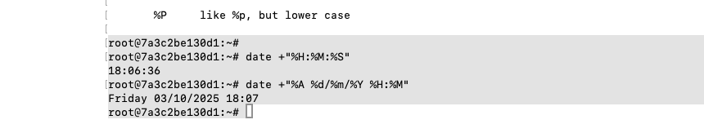

## **Case John - in Ubuntu container**

John wants to implement the date functionality in his Shell script. The script is searching for bad OS configuration on specific dates & times.

It's your task to find out how to *show the date and time* as output in the CLI, figure out if it's possible in the following format *thursday 25 sept 2025 09:15* with underneath the week number.

Congratulations John is 1 step further in his script.

The next question is that it only needs to run when there are *processes running with in the commandname* bash do this in full format listing. John will provide the if statement, so don't worry about that.  
Note: use the ps command.

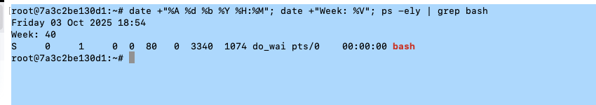

## **Editors - HOST computer**

Install Visual Studio Code on the host computer.  
In Visual Studio code install extension “Markdown All in One”.  
Create a Markdown file with the following contents.  
Header 1: Lab 1 Linux  
Text: this is the description of this lab.  
Set the word description in bold.  
Create an unsorted list with the following items: item1, item2, item3, item4  
Create a screenshot of the running Linux Container) and insert the saved image in the file.  
Copy this sceenshot in the Word document

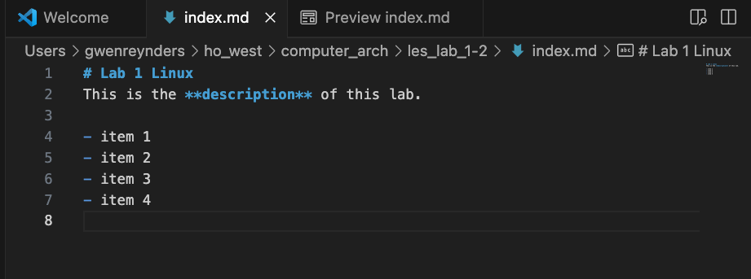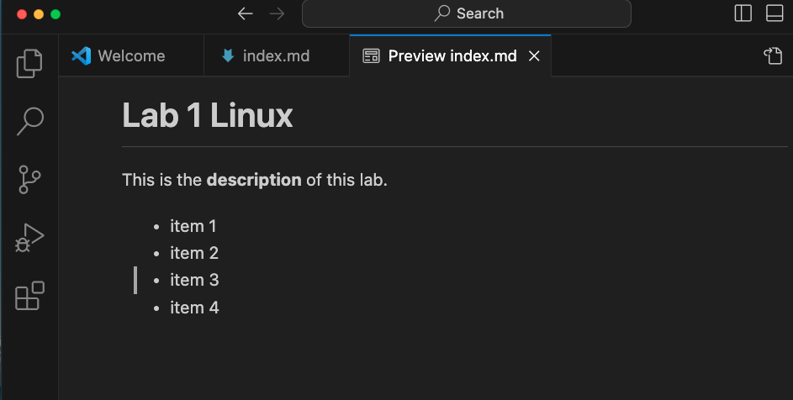

Create a screenshot of the running Linux Container) and insert the saved image in the file.

